An interactive tool to help health professionals predict the risk for invasive melanoma
An interactive tool designed by scientists at the National Cancer Institute (NCI), the University of Pennsylvania, and the University of California, San Francisco to estimate a person's absolute risk of developing invasive melanoma. The tool helps clinicians identify individuals at higher risk of melanoma and plan with them for appropriate screening interventions.
Before using the tool, please note the following:
- The melanoma risk calculator was designed for use by health professionals during a routine physical examination that includes patient history and an examination of the back and shoulders. If you are not a health professional, you are encouraged to discuss the results and your personal risk of melanoma with your doctor.
- The tool should not be used to estimate melanoma risk for people who have already had a diagnosis of melanoma, melanoma-in-situ, non-melanoma skin cancer, or a family history of melanoma. These individuals should be in screening and surveillance programs.
- This tool was developed using data from a large case-control study in the United States. The risks are estimated only for non-Hispanic whites; data on other ethnicities were too limited to accurately estimate risk.
- A recent version of Internet Explorer, Firefox, or Netscape is recommended.
We welcome use by other groups to test the model.
Questions
(Click a question number for a brief explanation, or read all explanations.)
1. Does the patient live in the Northern, Central, or Southern United States?
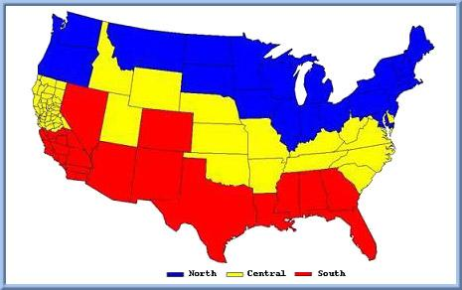
Caution: This map is only a guide. The final choice of region should be made by the health care provider. The model is valid only for residents of the continental United States.
Answer (in pull down menu form): North, Central, South
2. What is the patient’s gender?
Answer (in pull down menu form): Male, Female
3. What is the patient’s race?
Answer (in pull down menu form): Non-Hispanic White, Other*
*Pop-up: This tool can only accurately calculate melanoma risk for patients who are non-Hispanic white.
4. What is the patient’s age?
Answer (in pull down menu form): 19 or younger*, 20-70, 71 and older*
*Pop-up: This tool only calculates risk for patients between 20 and 70 years of age.
5. Has the patient ever had a blistering sunburn?**
Answer (in pull down menu form): Yes, No
6. Is the patient’s complexion light, medium, or dark?
Answer (in pull down menu form): light, medium, dark
7. After repeated and prolonged exposure to sunlight, at the age the patient is now, how tan would the patient’s skin become?***
Answer (in pull down menu form): very brown and deeply tanned, moderately tanned, lightly tanned, no tan at all
8. How many moles larger than 5mm in diameter are on the patient’s back?**
Answer (in pull down menu form): Less than 2, 2 or more
9. How many moles less than or equal to 5mm in diameter are on the patient’s back?
Answer (in pull down menu form): Less than 7, 7-16, 17 or more
10. How extensive is the freckling on the patient’s back and shoulders?
Mild Moderate Severe

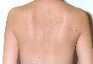
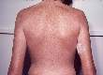

Answer (in pull down menu form): absent, mild, moderate, severe

11. Does the patient have severe solar damage on the shoulders?**
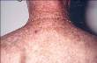
Example

Answer (in pull down menu form): Yes, No
CALCULATE RISK
**question is for males only, the calculator adjusts for this
***question is for females only, the calculator adjusts for this

